#### Minor Project Proposal of Bachelor in Computer Engineering

**Road Maintenance Complaint System**



#### **Submitted by:**

|  |  |
| --- | --- |
| **Aashutosh Sapkota** | **BEC [2077-01]** |
| **Hom Bdr. Pathak Kshetri** | **BEC [2077-16]** |
| **Abhishek Sharma** | **BEC [2077-02]** |
| **Rajeev Paudel** | **BEC [2077-24]** |

**United Technical College**

**Faculty of Science and Technology**

**Pokhara University, Nepal**

#### May, 2023

Abstract

Road accidents are incidents that occur on roads involving vehicles, resulting in damage to property, injuries, or even loss of life. These accidents can be caused by various factors, including human error, such as speeding, and reckless driving, as well as road conditions. With the recognition of such a problem, a web-based application aimed to solve the issue of poor road conditions is created.

The Road Complain Maintenance System aims to empower citizens to actively participate in improving road safety. Each individual has the power to report road conditions and maintenance requirements to the government. The project's goal is to develop a transparent and efficient system through which the public and government organizations may collaborate to improve road quality and prevent accidents. The system will be built using HTML, CSS, JavaScript, SQL, and PHP, ensuring a user-friendly interface and efficient data Management. The project is expected to take 10 weeks.

**KEYWORDS**: *Complaint, Register, Problem, Action, Acknowledgment, Authorized, Web etc.*

Table of Contents

Abstract ii

Table of Contents iii

List of Figures v

List of Tables vi

Acronyms and Abbreviation vii

Chapter 1: Introduction 1

1.1 Background 1

1.2 Problem statement 2

1.3 Objectives 3

1.4 Scopes 3

1.5 Limitation 4

1.6 Application 4

Chapter 2. Literature Review 5

2.1 Case study 5

2.2 Status of Road Maintenance in Nepal 7

Chapter 3: Methodology 9

3.1 Flow of project 10

3.1.1. Concept and Initiation 10

3.1.2. Definition and planning 11

3.1.3. Software Used 11

3.1.4 Development 12

3.1.4. Launch and Execution 13

3.1.5. Performance and Control 13

3.2 System design 14

3.2.2 E-R diagram 16

3.2.3 DFD (Data Flow Diagram) 17

3.2.4 : Use case Diagram 19

3.3 : Software and hardware requirement 20

Chapter 4: Time Estimation 21

Chapter 5: Epilogue 21

5.1 Expected Outcome 23

5.2 Budget Estimation 24

References 25

List of Figures

3.1: Flow of project, Road Complaint Maintenance System 8

3.2.1: System Flow Diagram 11

3.2.2: E-R Diagram for Road Complaint Maintenance System 11

3.2.3: System Architecture 11

3.2.4: Level 0 Data Flow Diagram 12

3.2.4: Level 1 Data Flow Diagram 13

3.2.4: Level 2 Data Flow Diagram 13

3.2.5: Use case Diagram 14

List of Tables

Table 1: Gantt chart of the project 16

Table 2: Budget Estimation 24

Acronyms and Abbreviation

|  |  |  |
| --- | --- | --- |
| CSS | : | Cascading Style Sheets |
| DFD | : | Data Flow Diagram |
| ERD | : | Entity Relationship Diagram |
| GB | : | Giga-Bytes |
| GDP | : | Gross Domestic Product |
| HTML | : | Hypertext Markup Language |
| HTTP | : | Hypertext Transfer Protocol |
| JS | : | JavaScript |
| MB | : | Mega-Bytes |
| PHP | : | Hypertext Preprocessor |
| RAM | : | Random Access Memory |
| RDBMS | : | Relational Database Maintenance System |
| SQL | : | Structured Query Language |
| VS Code | : | Visual Studio Code |
| XAMPP | : | Cross-Platform, Apache, MySQL, PHP and Pearl |
| XML | : | Extensible Markup Language |

# Chapter 1: Introduction

## Background

Roads play a crucial role in the transportation system of Nepal, serving as the primary mode of transport. In the past, roads were constructed without adequate consideration for future maintenance needs, resulting in a significant loss of road assets. On average, 5 km of road per year per 100 km of roads built were being lost. Even higher-standard roads, supported by donors, experienced a similar rate of decline. From 1988 to 1992, the length of roads in "poor condition" nearly doubled, and the overall condition of the major road network deteriorated rapidly, with approximately 180 km of good road being lost annually [1].

Unfortunately, the situation is further aggravated by the increasing number of road accidents and fatalities. The declining road quality, coupled with the growing volume of vehicles on the roads, has led to a surge in fatal accidents nationwide. According to the World Health Organization (WHO) report of 2013, more than three thousand people lose their lives daily due to road traffic accidents globally, with approximately 1.3 million annual fatalities. The alarming combination of poor road conditions and rising accident rates emphasize the urgent need for research to address these critical issues [2].

By investigating the factors contributing to road deterioration, exploring effective road maintenance strategies, and examining measures to enhance road safety, this proposed research aims to make significant contributions toward improving Nepal's road infrastructure and reducing the number of road accidents and fatalities. The deteriorating road conditions have contributed to an increase in accidents. Factors such as potholes, inadequate signage, poor road markings, and lack of maintenance have created hazardous conditions for drivers, pedestrians, and other road users. The combination of substandard road infrastructure and unsafe driving behaviors has resulted in a high number of road accidents, injuries, and fatalities in Nepal [3].

To address these challenges, the proposed solution of the Road Complain Maintenance System offers a web-based application to tackle the problem of poor road conditions. The system aims to empower citizens by providing them with a platform to actively participate in improving road safety. Through this system, individuals can report road conditions and maintenance requirements to the government, ensuring that concerns regarding road quality and safety are promptly addressed. The key objective of the Road Complain Maintenance System is to establish a transparent and efficient collaboration between the public and government organizations. By leveraging the power of citizen engagement, the system aims to enhance the quality of roads and prevent accidents. It provides a mechanism for citizens to report issues such as potholes, damaged signage, inadequate lighting, or any other factors that contribute to unsafe road conditions. These reports can then be reviewed and addressed by the relevant authorities responsible for road maintenance [4].

Road Complain Maintenance System offers a promising solution to the challenges faced in road Maintenance and the escalating accident rates in Nepal. By facilitating citizen engagement, promoting transparency, and enabling efficient collaboration between the public and government organizations, the system has the potential to significantly improve road conditions and enhance road safety. Through its implementation, Nepal can work towards achieving a safer and more sustainable road network [5].

## Problem statement

The roads in Nepal are currently plagued by several issues, including poor maintenance, inadequate infrastructure, and lack of timely repairs. However, one of the significant challenges exacerbating these problems is the absence of a dedicated governing body or mechanism to effectively listen to public concerns and address the road-related issues reported by citizens. The limited government budget allocations and historical negligence of future maintenance needs during road construction have resulted in deteriorating road conditions. The road network is facing a rapid decline, with an increasing length of roads falling into the category of "poor condition." These substandard road conditions pose significant risks to road users, leading to a surge in accidents, injuries, and fatalities [6].

The lack of an established framework for public participation and road complaint Maintenance further compounds the problem. Without a dedicated platform for citizens to report road conditions and maintenance requirements, concerns raised by the public often go unheard or unaddressed. This lack of responsiveness not only undermines public confidence but also perpetuates the cycle of poor road conditions and unsafe infrastructure [7].

We would solve this problem by implementing a user-friendly road Maintenance system which can help to address the challenges in road Maintenance. This system enables real-time monitoring, public reporting of road issues, streamlined maintenance processes, and improved communication between the government and the public.

## Objectives

The objectives of the proposed system are as follows:

1. To create a complaint dashboard for efficient monitoring, analysis, and decision-making in road maintenance.
2. To empower citizens by providing them with a platform to actively participate in road improvement.
3. To facilitate identifying areas requiring maintenance, repairs, or infrastructure upgrades for safer and more reliable road networks.

## Scopes

## Complaint submission: Users can report road complaints through the system's interface.

## Government collaboration: Facilitating collaboration between users and government agencies.

## Data Maintenance and analysis: Efficiently store and analyze complaint data.

## Mobile compatibility: Access and report complaints through mobile devices.

## Scalability: Capable of handling a large volume of complaints and future growth.

## System maintenance: Regular updates and enhancements.

## Public participation: Encouraging citizen involvement in road improvement.

## Road network improvement: Contributing to safer and more reliable road networks.

## Limitation

## Reliability of user-generated data: User-generated data may vary in accuracy and reliability, necessitating validation and verification mechanisms.

## Connectivity and access: Stable internet connection and access to smartphones or internet-enabled devices are necessary for system usage, potentially limiting its effectiveness in areas with connectivity issues.

## Application

The main concept of this website is to establish a platform that empowers citizens to actively participate in enhancing road safety and infrastructure. Through this platform, individuals can report road complaints, such as poor road conditions, inadequate signage, or other hazards. Also, to improve the overall quality and safety of the road network.

# Chapter 2. Literature Review

## Case study

**2.1.1 FixMyStreet**

FixMyStreet is an online platform that has revolutionized the way citizens engage with their local communities to address infrastructure problems. Launched in 2007, FixMyStreet provides a user-friendly website and mobile application that enables citizens to report various issues, such as potholes, broken streetlights, and graffiti, by pinpointing the problem's location on a map [8].

The primary objective of FixMyStreet is to empower citizens and establish a direct and efficient channel of communication with local government authorities. By utilizing the platform, citizens can actively participate in improving their community's infrastructure and contribute to the prompt resolution of reported issues. One of the key features of FixMyStreet is its user-friendly interface, making it easy for individuals to report problems seamlessly. Through the website or mobile app, users can accurately pinpoint the location of the issue on a map, facilitating swift identification and resolution. FixMyStreet promotes transparency and collaboration by providing real-time updates to users. Citizens can track the progress of their reported issues and receive updates on their resolution status, fostering a sense of engagement and accountability [9].

FixMyStreet's data collection and analysis have also proven valuable. By analyzing the reported issues, local authorities can gain insights into patterns, prioritize repairs based on severity, and allocate resources efficiently. This data-driven approach enables evidence-based decision-making and enhances resource utilization. FixMyStreet has transformed the way citizens engage with local authorities, fostering transparency, accountability, and collaborative problem-solving [10] .

**2.1.2 Roadify**

Roadify is an innovative application that has revolutionized the way road users access and share real-time information about road conditions, traffic congestion, and incidents. This mobile app provides a platform for users to report and communicate road-related updates, contributing to a collective pool of data that enhances awareness and assists drivers in making informed decisions [11].

The main concept behind Roadify is to create a community-driven network where users actively participate in sharing real-time road information. By utilizing the app, users can report road hazards, accidents, or road closures, providing valuable insights to other road users and relevant authorities. The success of Roadify can be attributed to several factors. The app harnesses the collective power of its user base, creating a vast network of real-time road information. This network effect enhances the accuracy and reliability of the reported information, benefiting all users who rely on the app for road updates.

Additionally, Roadify leverages data-driven insights to enhance the overall road experience. The app collects and analyzes user-generated data, enabling authorities to identify traffic patterns, areas prone to accidents, and infrastructure improvements. This data-driven approach supports evidence-based decision-making for road planning and Maintenance. Roadify enhances road safety and empowers individuals to make informed decisions while traveling [12].

**2.1.3 Street Bump**

Street Bump is an innovative case study that focuses on leveraging technology to improve road conditions. Developed by the City of Boston, Street Bump is a smartphone application that allows citizens to contribute to the identification of potholes and other road defects. The app uses the accelerometer and GPS sensors in smartphones to detect and record road irregularities as users drive along city streets. When a bump or pothole is detected, the app automatically sends the data, including the location and severity of the road issue, to the city's Department of Public Works [13].

The case study of Street Bump highlights the power of citizen engagement and crowdsourcing in gathering valuable data for road maintenance and repairs. By involving the community in reporting road defects, the city can prioritize and address maintenance needs more efficiently. This innovative approach not only improves the overall condition of the road network but also enhances transparency and accountability in government operations [13].

The success of Street Bump lies in its ability to harness the ubiquity of smartphones and engage citizens as active participants in the maintenance and improvement of city infrastructure. The data collected through the app helps the city identify areas in need of repair, allocate resources effectively, and provide a safer and smoother driving experience for residents and visitors. Moreover, the case study demonstrates the potential of technology-driven solutions in solving real-world challenges, transforming the way governments and communities collaborate for the benefit of all [13].

## Status of Road Maintenance in Nepal

There is little doubt that roads are arteries of development and can add to the overall quality of citizens’ lives. Sadly, if you talk about public roads in Nepal, national highways, strategic road networks, city roads, feeder roads, district roads, or rural roads—most of them have been clogged and turned into perils. Further, countless potholes, poor drainage systems, yawning ditches, several mismanaged manholes and sinkholes as well as other road-related infrastructural breakdowns have perennially added to the public woes [1].

 At the eleventh hour of every fiscal year, the government speeds up various developmental projects at the cost of sustainable infrastructures. Our contractors can be seen carrying out many developmental activities–digging ditches, laying sewerage pipelines, constructing and blacktopping roads, and setting up other road-related critical infrastructures, among others. Hence, the under-utilization of the budget for the substantial part of the fiscal year and gush in expenditure towards the end only makes matters worse, thus leading to rickety, shoddy, and substandard road-related infrastructures [1].

The Department of Road (DoR) and the Department of Local Infrastructure Development and Agricultural Roads (DoLIDAR) are government agencies responsible for the planning, construction, maintenance, and improvement of public roads and related infrastructure. They have the necessary institutional support, policies, legal frameworks, technical expertise, and human resources to carry out these responsibilities effectively [2].

Therefore, such perilous roads and road-related infrastructures require the serious attention of the concerned agencies of the government in order to identify the root causes and mitigate their potential costs.

# Chapter 3: Methodology

It provides a structured framework for executing and completing a project. In the context of this project, the methodology outlines the step-by-step process that will be followed to design, develop, and deploy the Road Complaint Maintenance System. The methodology encompasses various stages, each stage involves specific tasks and activities that contribute to the successful implementation of the project. The methodology ensures a systematic and organized approach, allowing for efficient project Maintenance and the achievement of project objectives [14].

The purpose of project methodology is to allow for controlling the entire Maintenance process through effective decision making and problem solving, while ensuring the success of specific processes, approaches, techniques, methods and technologies.

In the proposed methodology there are 4 different stages which are flow of project, system design, software and hardware requirement and testing and maintenance.

## Flow of project

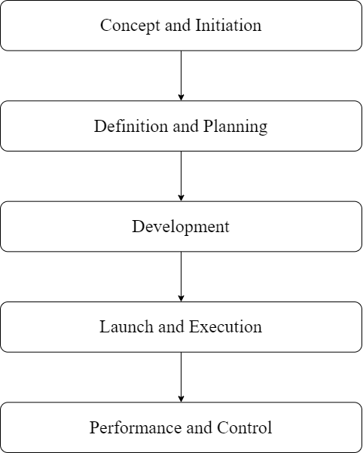

3.1: Flow of project, Road Complaint Maintenance System

(Group Study, 2023)

### Concept and Initiation

Before starting any project, it's important to collect and check if the requirements make sense. The project can continue if the requirements are feasible. During this phase, everyone involved in the project, like citizens and government officials, works together to gather all the necessary information needed to create and build the project. It's like putting together all the puzzle pieces to make sure we have everything we need. This way, the developers and designers can understand what needs to be done and create a system that solves road-related problems.

### Definition and planning

In our 'Road Complaint Maintenance System' project, our goal is to create a web application that facilitates the Maintenance of road complaints. The key components of the system include features for complaint submission by users, services for addressing the complaints, efficient administration and Maintenance of the system, and comprehensive tracking and resolution of reported road issues.

### Software Used

**1. XAMPP:** XAMPP is a widely used open-source software package that provides a complete web development environment. It stands for Cross-platform, Apache, MariaDB, PHP, and Perl. XAMPP includes all the necessary components to set up a local web server on your computer, including the Apache HTTP Server, MySQL database, PHP scripting language, and Perl programming language. It is a convenient solution for developers to create and test web applications locally before deploying them to a production environment. XAMPP is available for multiple operating systems and offers an easy-to-use interface for managing and configuring the server environment [15].

**2. Visual Studio Code:** VS Code is a popular source code editor developed by Microsoft. It is widely used by developers for various programming languages and platforms. VS Code offers a lightweight yet powerful environment with features like syntax highlighting, code completion, debugging, and Git integration. It supports a wide range of extensions that enhance functionality, allowing developers to customize their workflow. With its user-friendly interface and extensive community support, VS Code has become a preferred choice for many developers seeking a versatile and efficient code editor [16].

### 3.1.4 Development

In our "Road Complaint Maintenance System" project, we will utilize the following technologies:

**1. HTML:** HTML, which stands for HyperText Markup Language, is a markup language used for structuring and organizing web pages. It defines the elements and layout of a webpage, allowing us to create the basic framework of our application. By using HTML, we can arrange content, insert images, create links, and define the overall structure of our web pages [17].

**2. CSS:** CSS, short for Cascading Style Sheets, is a style sheet language used to control the presentation and appearance of web pages. It enables us to define styles, such as colors, fonts, layouts, and spacing, to enhance the visual appeal and user experience of our application. With CSS, we can create consistent and visually appealing designs across multiple web pages [18].

**3. JavaScript:** JavaScript is a programming language that adds interactivity and dynamic functionality to web pages. It allows us to create interactive elements, validate user inputs, handle events, and update content in real time. With JavaScript, we can implement features that respond to user actions, enhance the user interface, and make our application more engaging and user-friendly [19].

**4. PHP:** PHP is a server-side scripting language designed for web development. It enables us to handle server operations, process user inputs, and interact with databases. PHP is widely used for creating dynamic web pages, managing sessions, and generating content on the fly. In our project, we will utilize PHP to handle road complaints, manage user services, and perform database operations [20].

**5. MySQL:** MySQL is a popular relational database Maintenance system that provides efficient storage and retrieval of data. It allows us to create, manage, and query databases, making it ideal for storing road complaints, user information, and other relevant data. MySQL ensures data integrity, scalability, and reliability, enabling us to efficiently manage and organize information in our project [21].

**6. Apache2:** Apache2, also known as Apache HTTP Server, is a widely used web server software. It serves as the foundation for hosting and delivering web content to users over the internet. Apache2 supports multiple programming languages, handles client requests, and ensures secure communication between the server and clients. By using Apache2 as our web server, we can provide reliable and secure access to our road complaint Maintenance system [22].

**7. Bootstrap:** Bootstrap is an open-source front-end framework used to design and develop responsive websites and applications. It provides a library of pre-built components and styles, making it easier to create modern and visually appealing interfaces. With Bootstrap, developers can quickly build responsive layouts, incorporate interactive elements, and customize the design to meet their needs. The framework also offers cross-browser compatibility and mobile-first design principles, ensuring a seamless experience across different devices and screen sizes. Bootstrap is widely used in web development for its simplicity, versatility, and time-saving capabilities [23].

With these technologies, we aim to develop a robust and user-friendly "Road Complaint Maintenance System" that effectively handles road-related issues, provides a visually appealing interface, and ensures smooth user interactions.

### Launch and Execution

Once the development of our Road Complaint Maintenance System is complete, we will launch it for real-world usage. Users will be able to access the system, submit complaints, and interact with its features. We will ensure compatibility, conduct testing, and gather valuable user feedback to make necessary improvements.

### Performance and Control

We will continuously monitor the system's speed, stability, and scalability. Regular performance tests will be conducted to ensure it meets our project goals. We will also implement measures for data backup, security to maintain control and ensure a seamless user experience.

## . System design

After gathering and analyzing the requirements, it's time to give our Road Complaint Maintenance System a solid structure. In this phase, we'll design the architecture of the project based on the collected requirements. We'll create creative and intuitive diagrams like System flow, ER diagrams, System Architecture, DFDs (Data Flow Diagrams), and Use Cases.

These visual representations will help us visualize the system's structure, data flow, and interactions. By carefully designing the architecture, we'll set the stage for the successful development and implementation of our road complaint Maintenance system.

* + 1. **System flow Diagram**

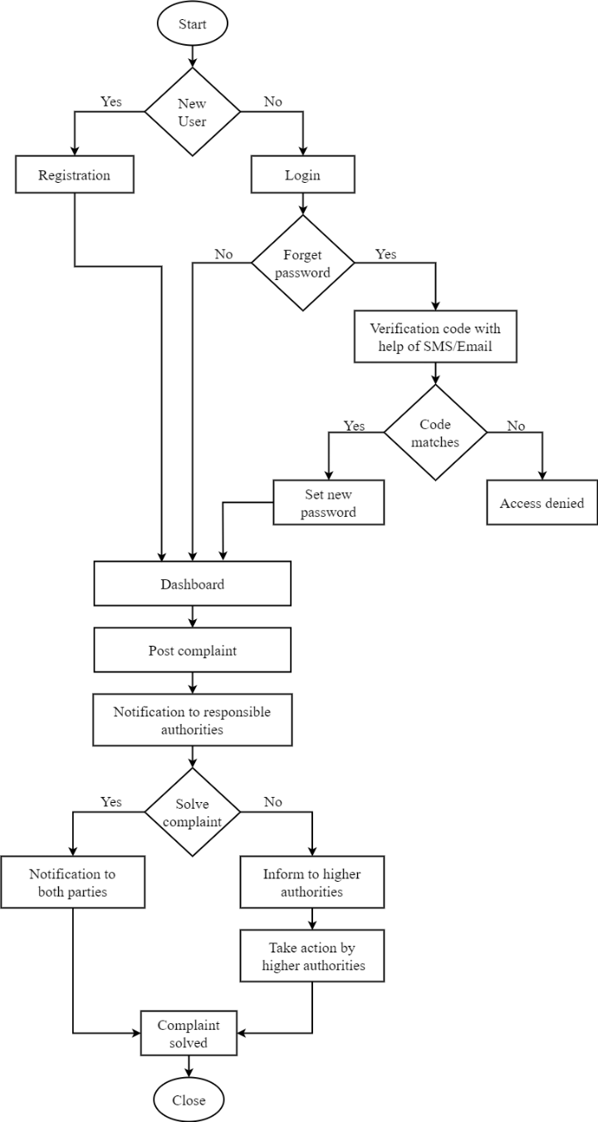

3.2.1: System Flow Diagram for Road Maintenance System

(Group Study, 2023)

### E-R diagram

E-R Diagram stands for Entity Relationship Diagram, also known as ERD is a diagram that displays the relationship of entity sets stored in a database. In other words, ER diagrams help to explain the logical structure of databases. ER diagrams are created based on three basic concepts: entities, attributes and relationships. ER Diagrams contain different symbols that use rectangles to represent entities, ovals to define attributes and diamond shapes to represent relationships. [24]

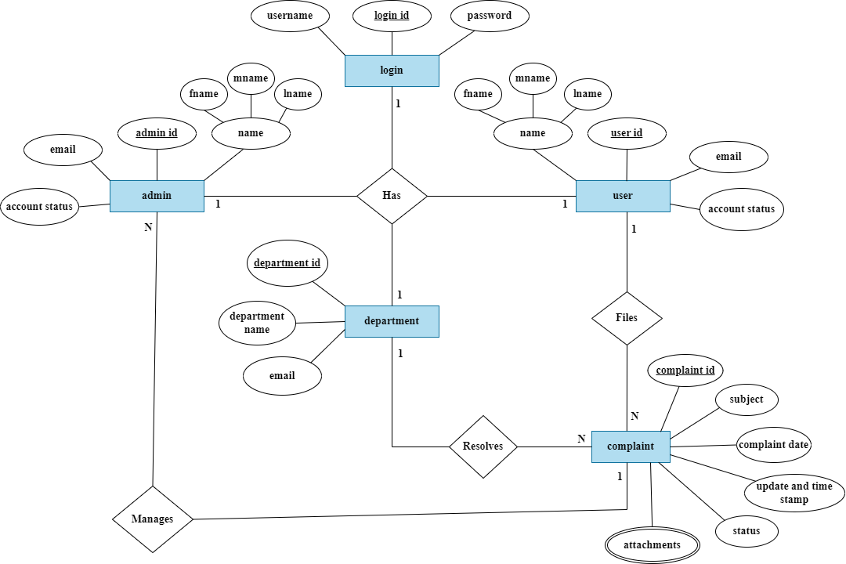

3.2.2: E-R Diagram for Road Maintenance System

(Group Study, 2023)

### DFD (Data Flow Diagram)

A Data Flow Diagrams (DFDs) are important tools for our Road Complaint Maintenance System project. DFDs visually show how data moves in our system, helping us find and fix issues to make it work better (Reference: Source). They give us a clear picture of how our system is built and what it does, making it easier for our team to work together (Reference: Source). DFDs can be used at different levels, from big pictures to small details, to help us design and improve our system.

They also help us understand how data connects and moves, ensuring everything works smoothly. By using DFDs in our project, we can improve our understanding, design, and implementation of the Road Complaint Maintenance System [25].

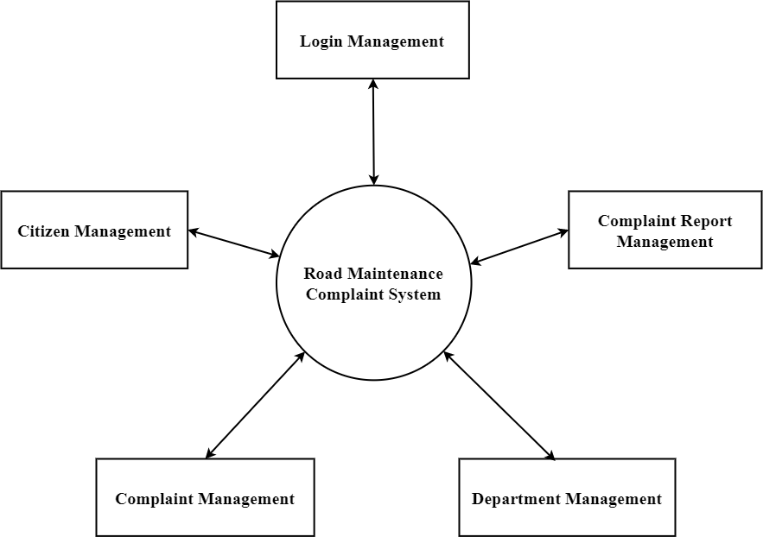

3.2.3: Level 0 Data Flow Diagram

(Group Study, 2023)

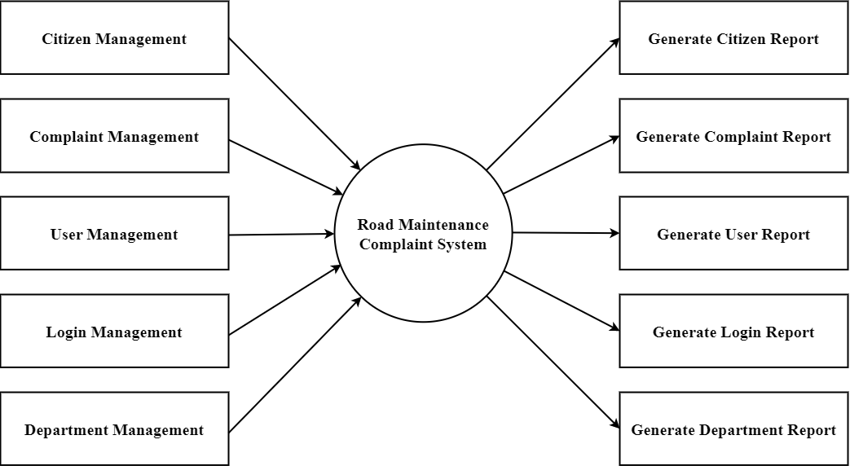

3.2.3: Level 1 Data Flow Diagram

(Group Study, 2023)

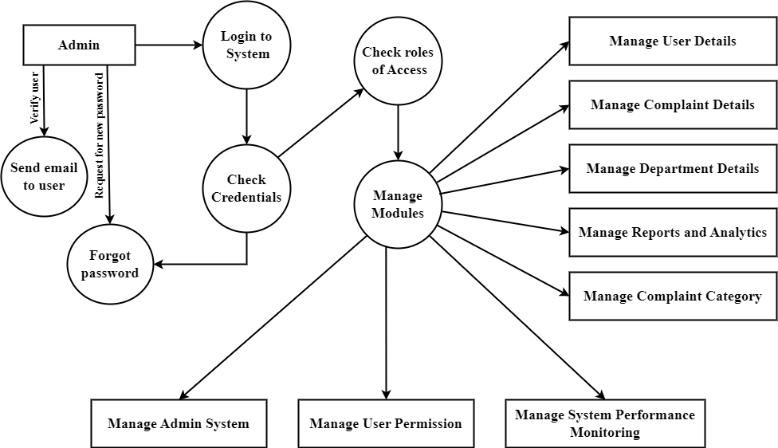

3.2.3: Level 2 Data Flow Diagram

(Group Study, 2023)

### Use case Diagram

A use case diagram is a graphical depiction of a user's possible interactions with a system. A use case diagram shows various use cases and different types of users the system has and will often be accompanied by other types of diagrams as well. [26]

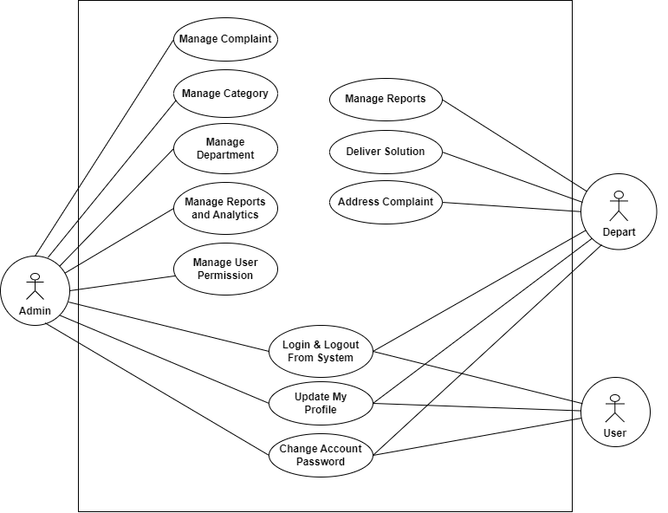

Figure 7: Use case Diagram

(Group Study, 2023)

## Software and hardware requirement

For our Road Complaint Maintenance System project, the hardware and software requirements are as follows: Hardware Requirements:

1. Mobile Devices: Any smartphone or tablet with an internet connection and a modern web browser.
2. Computers: Any desktop or laptop computer with an internet connection and a modern web browser. The system should be compatible with both Windows and macOS operating systems.
3. Software Requirements:
4. Operating System: Compatible with various operating systems, including Windows, macOS, Android, and iOS.
5. Web Browsers: Support for popular web browsers such as Google Chrome, Mozilla Firefox, Microsoft Edge, and Safari.
6. Responsive Design: The system should be designed and developed using responsive web design principles to ensure optimal user experience across different devices and screen sizes.
7. Cross-Browser Compatibility: The system should be compatible with multiple web browsers to ensure consistent functionality and appearance.

## By ensuring compatibility with a wide range of devices and operating systems, our Road Complaint Maintenance System can be accessed and used seamlessly by users on their smartphones, computers, and other devices.

## Testing and maintenance

Before deployment, it is imperative to subject any project to rigorous testing to ensure its adherence to expected behavior. Web applications run on any device that can access the internet which includes desktop computers, tablets, and mobile phones. Web applications are easily scalable, support multiple browsers and devices, platform independent and reduces the cost. Testing all the functionalities by providing appropriate input to verify whether the actual output is matching the expected output or not. It is used for checking the workflows, all the links of the web pages, form testing, cookie testing, and database connection. Ultimately, this testing phase plays a crucial role in mitigating potential issues before the application's release to end users.

# Chapter 4: Time Estimation

Before starting any project, it's important to create a clear schedule that outlines the tasks and milestones for the development phase. To ensure effective time Maintenance, we have prepared a Gantt chart covering a 3-month period, spanning 10 weeks from the phase after the proposal defense to the final report submission and defense. This schedule acts as a roadmap, helping us stay organized, track progress, and meet deadlines. By following the allocated time frames for each task, we can ensure efficient project execution and timely completion.

Table 1: Gantt chart of the project

|  |  |  |  |  |  |  |  |  |  |  |
| --- | --- | --- | --- | --- | --- | --- | --- | --- | --- | --- |
| Activities | Baisa kh | Jestha | | | | Ashad | | | | Shrawan |
|  | 24th | 1st | 2nd | 3rd | 4th | 1st | 2nd | 3rd | 4th | 1st |
| Literature review |  |  |  |  |  |  |  |  |  |  |
| Preparation of proposal |  |  |  |  |  |  |  |  |  |  |
| Proposal Defense |  |  |  |  |  |  |  |  |  |  |
| Coding initiation |  |  |  |  |  |  |  |  |  |  |
| Mid-Term Presentation |  |  |  |  |  |  |  |  |  |  |
| Coding Continuation |  |  |  |  |  |  |  |  |  |  |
| Report preparation |  |  |  |  |  |  |  |  |  |  |
| Final defense of project  report |  |  |  |  |  |  |  |  |  |  |

(Group Study, 2023)

1. **Jestha 1st Week:** During the initial phase of our project, we dedicated considerable time to deliberate and finalize the topic of our project. Once the topic was determined, we proceeded to undertake an extensive review of relevant literature, including project reports, articles, books, and journals, in order to comprehensively understand the existing body of knowledge on our chosen subject. This literature review exercise enabled us to identify any gaps in the current understanding and served as the basis for further project development.
2. **Jestha 2nd Week:** During the following week, our focus shifted towards preparing a comprehensive project proposal. This stage involved consolidating our research findings, refining the project objectives, and outlining the methodology to be employed.
3. **Jestha 3rd Week:** In the defense, we will present the structured framework of the proposal, showcasing the project's feasibility, resource requirements, and anticipated timeline. We will effectively communicate the potential impact and benefits of the project, emphasizing its value to stakeholders.
4. **Jestha 4th - Ashad 5th Week:** During the period from Jestha 4th to Ashad 5th week, our primary focus will be on coding for our web application. This phase involves the implementation of the project's functionality, user interface, and database integration. We will dedicate our efforts to writing and testing the code, ensuring that it aligns with the project requirements and objectives. Simultaneously, we are aware that we will have the mid-term defense scheduled for the 3rd week of Ashad.
5. **Shrawn 1st week:** This week marks the culmination of our project journey, as we reach the end of the 10th week. By diligently finalizing the project report and adhering to the submission requirements, we aim to conclude our project successfully and provide a valuable contribution to the respective department. Proper referencing and citation of sources will be maintained to uphold academic integrity.

# 

# Chapter 5: Epilogue

## 5.1 Expected Outcome

The expected outcome of our project is to improve road conditions in Nepal. By implementing our Road Complaint Maintenance System, we aim to achieve the following:

**1. Efficient Issue Reporting:** Provide a user-friendly platform for citizens to report road problems promptly and accurately.

**2. Timely Response:** Enable authorities to respond quickly to reported issues, leading to prompt repairs and maintenance.

**3. Road Safety Improvement:** Address problems like potholes, damaged signs, and unsafe conditions to enhance overall road safety.

**4. Data Analysis:** Collect and analyze data on reported issues to gain insights for decision-making and future infrastructure developments.

**5. Community Engagement:** Empower citizens to actively participate in road improvement efforts, fostering a sense of community involvement.

**6. Transparency and Accountability:** Ensure visibility and accountability in addressing reported issues, building trust and confidence in the system.

Our project aims to create an effective system that streamlines issue reporting, enhances road safety, promotes community engagement, and ensures accountability in addressing road-related problems.

## 5.2 Budget Estimation

Table 2: Budget Estimation of the project

|  |  |  |  |  |
| --- | --- | --- | --- | --- |
| Development Activity/Task | Status | Estimated Days | Estimated Hours | Estimated Budget |
| Requirement Analysis | Complete | 7 | 45 | $0 |
| Walk-through & Correction | Complete | 5 | 10 | $0 |
| Domain | In progress | - | - | $10 |
| Hosting | In progress | - | - | $14 |
| DB Design | In progress | 7 | 30 | $200 |
| UI/UX Design | In progress | 6 | 20 | $50 |
| Testing the system | In progress | 5 | 15 | $500 |
| Report writing and final report | In progress | 10 | 10 | $0.99 |
| **Total Cost** | | 40 | 130 | $774.99  102,783.84NPR. |

(Group Study, 2023)

# References

|  |  |
| --- | --- |
| [1] | D. N. Chalise, "ROADS BOARD NEPAL: A SUSTAINABLE APPROACH TO ROAD MAINTENANCE MANAGEMENT," *Transport and Communications Bulletin for Asia and the Pacific,* vol. I, p. 81, 2005. |
| [2] | K. Dhakal, "Road Traffic Accidents in Kathmandu Valley," *Journal of Health Promotion,* 2018/11/25. |
| [3] | K. C. B. Adhikary, "Road Traffic Accident and its Characteristics in Kathmandu Valley," *JNMA; journal of the Nepal Medical Association,* vol. 55, 2016. |
| [4] | E. A. Osman Nasr, "ONLINE COMPLAINT MANAGEMENT SYSTEM," *International Journal of Innovative Science, Engineering & Technology,* vol. II, 2015. |
| [5] | P. Kormpho, P. Liawsomboon, N. Phongoen and S. Pongpaichet, "Smart Complaint Management System," *ICT International Student Project Conference,* vol. I, p. 6, 2018. |
| [6] | "GULF TIMES," 3 nov 2017. [Online]. Available: https://www.gulf-times.com/story/569832/Poor-road-conditions-weak-laws-blamed-for-Nepal-tr. [Accessed 22 may 2023]. |
| [7] | ying, "xinhuanet," 1 11 2017. [Online]. Available: www.xinhuanet.com. [Accessed 22 5 2023]. |
| [8] | Frequently Asked Questions, "FixMyStreet," 2007. [Online]. Available: https://www.fixmystreet.com/faq. [Accessed 22 5 2023]. |
| [9] | King and S. F, "Fix my street or else: using the internet to voice local public service concerns," 2007. |
| [10] | Alvin, V. Moere and Andrew, "FixMyStreet Brussels: socio-demographic inequality in crowdsourced civic participation," *Journal of Urban Technology,* vol. 24, 2017. |
| [11] | Roadify team, "Roadify," [Online]. Available: https://roadify.com/. [Accessed 22 5 2022]. |
| [12] | Sagar Mahurkar, Robert Vigeant, Alexander Wald, Sean Watson, "Incorporation of the Roadify API in Ride," 2015. |
| [13] | boston.gov, "Boston," street bumps, 1 7 2019. [Online]. Available: https://www.boston.gov/transportation/street-bump. [Accessed 22 5 2023]. |
| [14] | K. B. M. Noor, "Case study: A strategic research methodology," *American journal of applied sciences,* vol. 5, pp. 1602--1604, 2008. |
| [15] | A. friends and K.Seidler, XAMPP: Simplifying web development with an all in one solution, IEEE Internet Computing. |
| [16] | Microsoft Corporation , A Collaborative Source Code Editor, IEEE Software . |
| [17] | T. Berners-Lee and e. al, "Hypertext Markup Language (HTML)," IEEE Transactions on Communications , 1991. |
| [18] | H. W. Lie and B. Bos, Cascading Style Sheets, IEEE Internet Computing , 1997. |
| [19] | B. Eich, JavaScript: A High-Level, Interpreted Programming Language for Web Development, IEEE Transactions on Software Engineering, 1997. |
| [20] | R. Lerdorf, "PHP: Personal Home Page Tools," 1996. [Online]. Available: https://www.php.net/manual/en/intro-whatis.php. [Accessed 22 5 2023]. |
| [21] | L. E. Ullman, "MySQL 8.0 Reference Manual," 2006. [Online]. Available: https://dev.mysql.com/doc/refman/8.0/en/. [Accessed 22 5 2023]. |
| [22] | Apache Software Foundation community, Apache HTTP Server: An Open-Source Web Server Software, IEEE Software. |
| [23] | J. T. M. Otto, Bootstrap, IEEE Internet Computing. |
| [24] | P. P. Chen, The Entity-Relationship Model: Toward a Unified View of Data, IEEE Transactions on Software Engineering, 1997. |
| [25] | Satzinger and Jackson, Systems Analysis and Design in a Changing World., Boston: MA: Cengage Learning, 2011. |
| [26] | I. Jacobson, Object-Oriented Software Engineering: A Use Case Driven Approach, IEEE Transactions on Software Engineering, 1992. |
|  |  |
|  |  |
|  |  |